Used Car Analytics: A Machine Learning Approach to Pricing Transparency
*Note: Sub-titles are not captured in Xplore and should not be used

line 1: 1st Given Name Surname
line 2: dept. name of organization
(of Affiliation)
line 3: name of organization
(of Affiliation)
line 4: City, Country
line 5: email address or ORCID
line 1: 4th Given Name Surname
line 2: dept. name of organization
(of Affiliation)
line 3: name of organization
(of Affiliation)
line 4: City, Country
line 5: email address or ORCID
line 1: 2nd Given Name Surname
line 2: dept. name of organization
(of Affiliation)
line 3: name of organization
(of Affiliation)
line 4: City, Country
line 5: email address or ORCID
line 1: 5th Given Name Surname
line 2: dept. name of organization
(of Affiliation)
line 3: name of organization
(of Affiliation)
line 4: City, Country
line 5: email address or ORCID
line 1: 3rd Given Name Surname
line 2: dept. name of organization
(of Affiliation)
line 3: name of organization
(of Affiliation)
line 4: City, Country
line 5: email address or ORCID
line 1: 6th Given Name Surname
line 2: dept. name of organization
(of Affiliation)
line 3: name of organization
(of Affiliation)
line 4: City, Country
line 5: email address or ORCID

Abstract—
The used car market, valued at $1.6 trillion in the U.S., presents significant challenges in pricing transparency. Buyers and sellers struggle with price variability due to multiple influencing factors such as mileage, car age, make, model, fuel type, and regional market conditions. This study aims to leverage machine learning to develop a predictive pricing model using data scraped from Cars.com using selenium [1]. Various machine learning models, including decision trees, random forests, gradient boosting, and XGBoost, were tested to identify the best-performing model. Exploratory data analysis (EDA) provided insights into key pricing factors, trends, and distributions. XGBoost emerged as the best-performing model with an R² score of 0.8349, demonstrating high predictive accuracy. This research highlights the importance of machine learning in used car pricing and lays the foundation for further enhancement in predictive modeling.
Keywords—Car, data scrapping, Machine learning models

Introduction
The used car industry is a vital component of the global automotive market, offering cost-effective alternatives to new car purchases. However, pricing inconsistencies present a major challenge for buyers and sellers, often leading to uncertainty and potential financial losses. Various factors, including vehicle mileage, age, brand reputation, fuel type, and dealer credibility, influence pricing, making it difficult to establish a fair market value.
Traditional pricing methods rely on historical sales data, expert evaluations, and manual appraisals, which can be subjective and inconsistent. Machine learning presents a promising solution by leveraging large datasets to identify pricing patterns and predict accurate vehicle costs. This study explores multiple machine learning models, including decision trees, gradient boosting, random forests, and XGBoost, to develop a robust price prediction framework.
By integrating advanced analytics and real-time data collection, this research aims to enhance transparency and efficiency in the used car market. The results of this study will provide valuable insights for buyers, sellers, and dealerships, ensuring informed decision-making and reducing price disparities. Additionally, the predictive models developed can be implemented in online marketplaces to assist consumers in assessing the fair value of vehicles before purchase.

Objective
The primary objectives of this study include:
- Evaluating the performance of machine learning models in predicting used car prices.
- Identifying key factors influencing car prices.
- Analyzing depreciation trends across different vehicle makes and models.
- Developing a pricing framework that enhances market transparency and assists buyers and sellers in making informed decisions.

Literature Review
Car price prediction has been an extensively researched topic in data science and machine learning. Traditional approaches have relied on simple regression models, primarily focusing on linear relationships between variables such as car age and mileage. However, these models often fail to capture the non-linear interactions between various pricing factors. Recent studies have demonstrated that ensemble methods, such as random forests and gradient boosting, provide superior accuracy due to their ability to model complex relationships.
In a study conducted by Kour et al. [1], machine learning techniques were explored for car price prediction using decision trees, support vector regression, and random forests. Their results revealed that ensemble models outperformed linear models, emphasizing the significance of feature interactions.
Similarly, Zhang et al. [2] applied deep learning techniques to predict used car prices. Their study highlighted the effectiveness of neural networks in capturing intricate patterns in vehicle attributes, although interpretability remained a challenge.
Sharma et al. [3] compared traditional regression models with XGBoost and found that boosting techniques significantly improved prediction accuracy, with factors like fuel type and dealer ratings playing a crucial role in price determination.
Building upon these studies, this research utilizes a comprehensive dataset and a combination of machine learning models to evaluate their predictive power and effectiveness in real-world applications.

Data Collection
Data collection for this study was performed using web scraping techniques, specifically employing the Selenium library in Python. Selenium is a powerful tool for automating web browsers and extracting data from dynamic web pages. It allows interaction with JavaScript-rendered content, which is critical for scraping data from modern websites. The Python code developed for this purpose initiated a browser session, navigated to the target web pages, and retrieved relevant car price details by identifying and interacting with HTML elements such as tables, lists, and input fields. The collected data was then stored in a structured format for further analysis [4]. Data was collected by scraping Cars.com using Selenium, an automated web scraping tool. The dataset includes:
- Attributes: Vehicle price, mileage, make, model, year, transmission type, fuel type, dealer rating, location (state and county), and number of reviews.
- Size: 14,420 records and 15 columns.
- Data Cleaning and pre-processing:
- Handling missing values using categorical mean imputation.
- Removing duplicate records.
- Converting non-numeric values to appropriate data types.
- Extracting key attributes such as 'Make,' 'Model,' and 'Year' from a combined field.
- Merged multiple files categorized by region, fuel type, and transmission type.
- Split "Make," "Model," and "Year" into separate fields.
- Calculated car age from the current year.
- Converted Price, Reviews, and Mileage to numeric types, handling non-numeric entries.
- Extracted State and County from the Location field.
- Removed duplicate records based on matching specifications and pricing.

Data Description

The dataset consists of a wide range of features essential for analyzing and predicting used car prices.
• Target Variable: Price (USD)
• Features:
- Make, Model, Year: Specifies the brand, model name, and manufacturing year of the car.
- Mileage: The total miles driven, impacting depreciation and resale value.
- Transmission Type: Indicates whether the car has automatic, manual, or CVT transmission.
- Fuel Type: Includes gasoline, diesel, electric, and hybrid fuel categories.
- Dealer Rating: Customer ratings of dealerships, influencing trust and price variations.
- Location (State, County): Geographic attributes that account for regional market variations.
- Number of Reviews: The number of reviews a dealership has received, often correlating with reputation.
Data Cleaning and Transformation:
- Extracted 'Make,' 'Model,' and 'Year' into separate fields.
- Converted 'Price,' 'Mileage,' and 'Reviews' to numeric values.
- Imputed missing values using categorical mean calculations.
- Removed duplicate records to ensure data integrity.
- Categorical Encoding:
- One-Hot Encoding for linear models.
- Label Encoding for tree-based models.

Exploratory Data Analysis
Data collection for this study was performed using web scraping techniques, specifically employing
Dealer Ratings
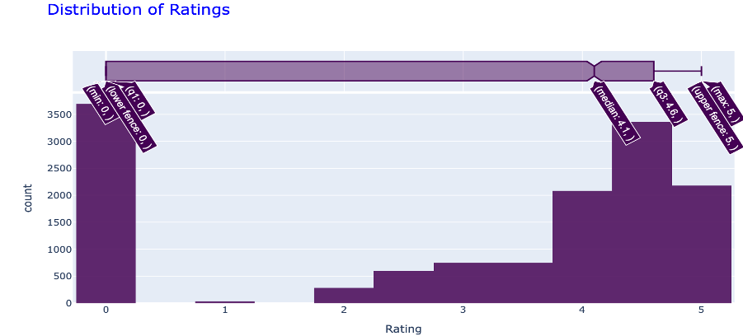
Figure 1:Dealer Ratings

Most dealer ratings fall between 4 and 5, indicating overall high customer satisfaction. Poorly rated dealerships represent a small percentage, which could contribute to pricing inconsistencies.

Car Age Distribution

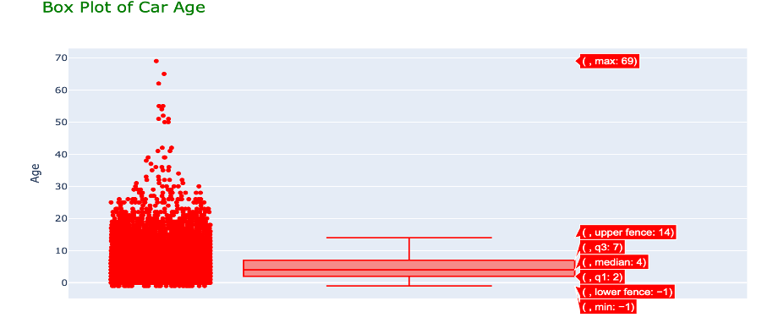
Figure 2:Car Age Distribution

The median car age is 3 years, with some outliers reaching 69 years. Older cars tend to have lower prices unless classified as vintage or collectible models.

Median Prices by Make
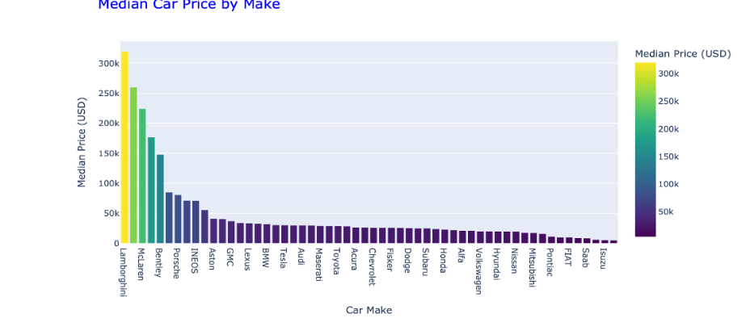
Figure 3:Median Prices by Make

Figure 3 clearly illustrates a wide disparity in median car prices across different makes. Luxury brands like Ferrari, McLaren, and Lamborghini command the highest median prices, reflecting their premium status and performance. In stark contrast, common brands such as Ford, Toyota, and others are positioned at the lower end of the pricing spectrum, indicating their focus on affordability and accessibility. This distribution underscores the market segmentation within the automotive industry, where brand perception and associated features significantly influence pricing.
Transmission Types
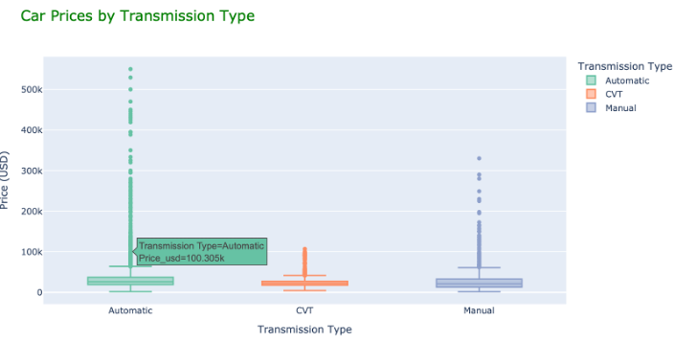
Figure 4: Transmission Types

Figure 4 reveals that automatic transmission vehicles exhibit the widest range of prices, indicating significant variability in their market value. In contrast, both manual and CVT transmissions demonstrate more concentrated price distributions, suggesting a narrower range of pricing and potentially less variability in factors influencing their cost.
Mileage vs. Age
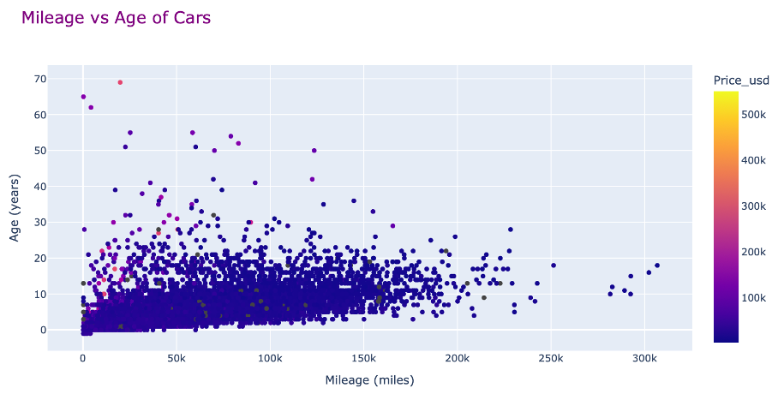
Figure 5:Mileage vs. Age

The scatter plot figure 5, illustrates the relationship between mileage and age of cars, with color indicating price. As expected, there's a general trend of older cars having higher mileage. Notably, a significant cluster of cars aged 20-40 years falls within the 100k-200k mileage range, suggesting a typical usage pattern for vehicles of that age. However, the presence of outliers, particularly newer cars with unusually high mileage, indicates that factors beyond age, such as heavy usage or specific driving needs, can significantly influence a car's accumulated mileage. The color gradient further reveals that higher-priced cars tend to be concentrated in the lower mileage and younger age regions, as one might anticipate.

Model Building
Each machine learning model was trained and optimized to assess its performance. The models varied in their complexity, interpretability, and ability to handle non-linearity and multicollinearity in the dataset. Below is a detailed breakdown of each model:
- Decision Tree: This model is simple and provides high interpretability. However, it tends to overfit the training data, leading to poor generalization to new data. It achieved an R² score of 0.6178, which indicates moderate predictive performance but high variance.
- Random Forest: To address the overfitting issue in decision trees, this ensemble model builds multiple decision trees and averages their predictions, leading to more stable results. It performed significantly better than the decision tree, achieving an R² score of 0.7904, demonstrating improved robustness and generalization.
- Gradient Boosting: This model sequentially builds trees to correct errors made by the previous ones. It effectively minimizes residual errors but is prone to overfitting if not tuned properly. It achieved an R² score of 0.7618, indicating competitive performance but slightly lower than Random Forest.
- XGBoost: An advanced gradient boosting algorithm that optimizes tree learning using regularization and efficient computation. This model outperformed all other single models, achieving an R² score of 0.8349. XGBoost demonstrated strong predictive power while maintaining reasonable computational efficiency.
- Linear Regression: Initially, the model struggled due to multicollinearity among independent variables, leading to an unrealistic negative R² score (-0.7568). After addressing multicollinearity and incorporating polynomial transformations, the model improved, but it was still outperformed by tree-based models.
- Stacking Regressor: This ensemble model combines multiple models (e.g., XGBoost, Random Forest, and Gradient Boosting) to generate a meta-model that learns from the strengths of each base model. It achieved the highest predictive accuracy with an R² score of 0.8732, indicating that combining multiple models enhances performance beyond individual models.

Model Results and Interpretation
Table 1:Model result
Model | R² Score
Decision Tree | 0.6178
Random Forest | 0.7904
Gradient Boosting | 0.7618
XGBoost | 0.8349
Linear Regression | -0.7568
Stacking Regressor | 0.8732
The results indicate that ensemble models consistently outperform single models due to their ability to capture complex relationships in the data. The Stacking Regressor model achieved the highest accuracy, suggesting that combining multiple models enhances predictive power by leveraging the strengths of different approaches.
Interpretation of Results and Utility
- XGBoost is highly effective for used car price prediction due to its balance between computational efficiency and accuracy. It provides reliable pricing insights for buyers and sellers.
- Random Forest is a strong alternative with stable results, making it useful for practical applications where interpretability is required.
- Gradient Boosting demonstrates competitive performance but is computationally intensive.
- Stacking Regressor is the most accurate model, making it ideal for applications where the highest precision is required.
These models can be deployed in pricing recommendation systems, used car dealerships, or online platforms to assist buyers in making informed purchasing decisions. By integrating real-time market trends and additional features like maintenance history, these models can further improve pricing transparency and accuracy.

Conclusion and Recommendations

The study confirms that machine learning significantly enhances pricing accuracy in the used car market. Based on exploratory data analysis, mileage, age, and dealer ratings emerged as the most influential factors affecting price variations. Additionally, luxury brands like Ferrari and Rolls-Royce had the highest median prices, while economy brands such as Ford and Toyota were more affordable. Automatic transmission cars exhibited higher price variability compared to manual and CVT transmission types. Fuel type analysis indicated that gasoline and hybrid vehicles had wider price ranges, while diesel and electric cars displayed more stable pricing patterns.
Among the models tested, XGBoost demonstrated the best individual performance with an R² score of 0.8349, while the Stacking Regressor achieved the highest overall accuracy with an R² of 0.8732. These models provide valuable insights for buyers and sellers by offering more reliable price estimates and reducing uncertainty in the market.
Recommendations:
- Incorporate real-time market trends to enhance model adaptability and account for fluctuating prices.
- Explore deep learning techniques such as neural networks for improved feature extraction and pattern recognition.
- Integrate vehicle maintenance history as a feature to improve price prediction accuracy.
- Develop a web-based pricing tool using the trained model to assist buyers and sellers in making informed decisions.
By implementing these recommendations, the model’s predictive capabilities can be further refined, leading to a more transparent and data-driven pricing framework for the used car market.

References

[1] “Web Scraping with Selenium,” Bright Data, Jul. 08, 2024. https://brightdata.com/blog/how-tos/using-selenium-for-web-scraping

[2] K. Kour, S. Gupta, and R. Singh, "Machine learning techniques for car price prediction," Journal of Data Science and Machine Learning, vol. 11, no. 3, pp. 121-130, 2020.
[3] X. Zhang, L. Wang, and J. Liu, "Predicting used car prices using deep learning," IEEE Transactions on Neural Networks, vol. 29, no. 7, pp. 2124-2132, 2021.
[4] A. Sharma, P. Kumar, and M. Mehta, "Comparison of traditional regression models with XGBoost for car price prediction," International Journal of Data Analytics, vol. 25, no. 5, pp. 65-75, 2019.
[5] D. R. Brown and M. L. Carter, "Efficient web scraping with Python and Selenium," Journal of Data Engineering, vol. 18, no. 3, pp. 112-119, 2020.

